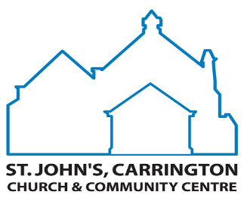
Promise Form and Gift Aid Declaration
You can alter your giving at any time should your circumstances change

To the PCC of St Johns Carrington
I should like to give / I am unable to give (please circle as appropriate)
Name …….. …………………………….. ……………………………….
(Capitals) Title Forenames Surname
(If you are giving through Gift Aid, please enter only one person’s name above)
Address ……………………………………………………………………………………………………….
…………………………………………. POST CODE ……………………………………….
£ ………
I should like to give Each Week / Month / Quarter
I choose to give by: Bank Standing Order

Offering Envelopes
Other (Please specify) ………………………………………………
Please TICK to treat as Gift Aid donations all qualifying gifts of money made from the date of this declaration and in the past 4 years.
I am a UK tax payer and understand that if I pay less Income Tax and/or Capitol Gains Tax than the amount of Gift Aid claimed on all mydonations in that tax year it is my responsibility to pay any difference. Please notify the Treasurer / Planned Giving Secretary if you want to cancel this declaration, change your name or home address or no longer pay sufficient tax on your income and/or capitol gains.

Signature ……………………………………………………… Date ……………………………….. If you have ticked that you are able to give by Bank Standing Order, please complete the form opposite OR tick one of the boxes below, if appropriate.
I have arranged the Bank Standing Order payments by phone or internet banking, and these payments will start on …………

There is no change to my existing Bank Standing Order payment.
Please return both parts of the form (address below). Thank You
Standing Order Form for St John’s Church Carrington
Please complete this form to set up a new standing order or if you would like to change the amount you give.
To the Manager ………………………………………………………………………………….Bank plc
Address ……………………………………………………………………………………………………….
…………………………………………. POST CODE ……………………………………….

Account Number __ __ __ __ __ __ __ __ Sort Code __ __ __ __ __ __

Name of Accountholder(s) …………………………………………………………………………….
Address ……………………………………………………………………………………………………….
…………………………………………. POST CODE ……………………………………….
Please pay to:
TSB Bank plc,
583 Mansfield Road
Sherwood, Nottingham NG5 2JN

A/C Name: Parochial Church Council of St John’s Carrington Account Number 00095139 Sort Code 30 – 97 – 55
Monthly / Quarterly payments of :-
(Please circle preference)

£__ __ __ . __ __ (__ __ __ __ __ __ __ __ __ __ __ __ pounds __ __ __ __ p)
Starting on the ……………. day of ………………………………………….…… 20 ………………
and continue these payments until further notice.
(Please choose a date at least one month from today to allow time for processing)

Once completed, please return to the Treasurer, Mr. Peter Artis:

39 Compton Road
Sherwood
Nottingham
NG5 2NH

Or email: peter.artis@ntlworld.com

